Name___________________________________
Introduction to Technology – 7
Sail Boat Unit Review Sheet
- Label the parts of the sailboat.

- Who is Bernouli and how did his principle apply to sailboats?

- What types of drill bits have we used in class?

- Compare and contrast Bernouli’s Principle and Newton’s Third Law as it applies to sailing.

Directions: Match the answer on the left with the definition on the right.
5. Bow _____ | A. Left side of boat
6. Mast _____ | B. Friction
7. Beam ______ | C. Vertical spar that holds sail
8. Sail _____ | D. Prevents skidding
9. Port _____ | E. The “body” of the boat
10. Starboard _____ | F. Right side of boat
11. Keel _____ | G. The front of the boat
12. Drag _____ | H. The rear of the boat
13. Hull _____ | I. A device used to catch the wind
14. Stern _____  15. Explain how a boat floats.  16. Sketch a top and side view of a sail boat  17. Label all the steps in the Problem Solving Process | J. The width of the boat
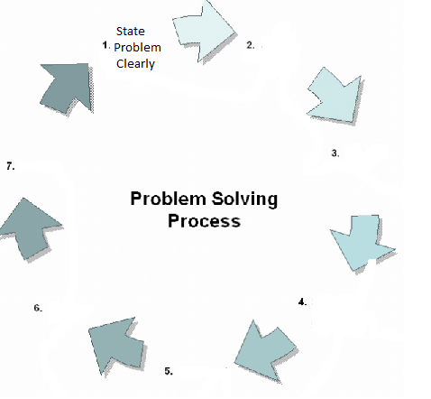
18. Why isn’t the miter saw used to cut inside angles?

19. How are sailboats able to sail into the wind?

20. Why do you not shake the can of clear coating before applying?

21. Explain in detail all the steps taken and tools used to make the sailboat.

